A

Proposal

On

Feedback System

For the partial fulfillment of the requirements for the degree of Bachelor of Computer Application under Pokhara University

**Submitted To**

Department of Computer Application

National Academy of Science and Technology

**Under the Supervision of**

Mr. Sunil Bahadur Bist

Lecturer, Department of Computer Application

**Submitted By**

Jasmir Chaudhary (23530008)

Nabin Kumar Bhatta (23530016)

Sumitra Thagunna (23530034)

Sunil Bahadur Singh (23530035)

Bachelor of Computer Application, 4th Semester

May, 2025



National Academy of Science and Technology

(Affiliated to Pokhara University)

Accredited by University Grants Commission (UGC), Nepal (2022)

Uttarbehedi 4 Dhangadhi, Kailali, Nepal

# Abstract

The Feedback System is a project which aims to develop a computerized system to get reach to all the complaints and dis satisfaction of students as well as guardians towards the college. This feedback Management System project provides fast, efficient, and secure platform to share dis satisfaction and complaints. Overall, this project of ours is being developed to help the students as well as the staffs of the school to maintain the college in well-disciplined manner and to solve the problems of students as well as staff view in the best way.

***Keywords: Feedback System, College Feedback System, Web-based Platform, Flask Framework, SQL Database, Role-Based Access Control***

## 1. Introduction

The Feedback System is a web-based platform designed to streamline and digitize the process of collecting managing, and analyzing feedback from students and staffs related to specific college. It also facilitates administrators in monitoring, managing, and resolving these feedback or complaints efficiently.

It is built using Python’s Flask framework and backed by a SQL database, the system offers a user-friendly interface for both regular users and administrators. Users can register, log in, and submit their feedback, which is then securely stored and organized within the database.

Our system ensures data privacy and includes essential features such as authentication, password recovery for users as well as for admins and admin login with predefined credentials. Additionally, the addition of a “Forgot Password” feature enhances usability, allowing users to retrieve their credentials and admins to contact the developer if needed.

Overall, the Feedback System is a practical and scalable solution aimed at improving transparency, accountability, and responsiveness in feedback handling processes.

## 2. Problem specification

Problem Specifications helps to outline the key challenges that our Management System aims to address. In many organizations collecting and managing user feedback manually is time consuming, inefficient, and prone to data loss or miss-management. These issues result in poor communication, delayed responses, and lack of actions regarding problems. Thus, a streamlined, transparent online solution is required and our “Feedback Management System” can solve that.

The main problems that are in existing system are:

* Manual feedback collection is inefficient and error-prone.
* Delayed Responses.
* Loss or Misplacement of feedbacks or data.
* Users face difficulty in sharing feedback conveniently
* No Transparency.
* Poor Record Maintenance
* Difficult for Administrators to Prioritize

## 3. Objective

The main objective of the **Management System** project is to create a reliable and user-friendly platform where users can submit their feedback, and admins can efficiently manage and respond to that feedback.

Objectives of the project:

* To develop a secure login and registration system for users and admins.
* To provide an admin dashboard to manage and resolve complaints.
* To implement a "Forgot Password" feature for password recovery and support.
* To provide login-based (user and admin) access control to separate user and admin functionalities.
* To minimize paper-based feedback processes and enhance digital efficiency.

## 4. Related Work Review

The related work review helps us to examine existing feedback management systems to improve our proposed Feedback System. Here we analyzes similar systems, their abilities and drawbacks in detail.

From the reviews below we got knowledge about how to improve functionality of our system. This related work reviews helped us to know defects in our system and we also got ideas to improve our system in more usable and functional way.

Some of similar related work are listed and reviewed below:

**Aptean Complaint Management System**

Aptean provides a Complaint Management software for business, focusing on capturing, tracking, and resolving customer complaints.

Strategies for making it reliable and drawbacks which we got in this system are listed below:

**Strategies**

1. Respond Faster
2. Respond Smarter
3. Respond Confidently
4. Respond Easily

**Drawbacks**

1. They are only for commercial use.
2. There is limited customization.
3. High complexity and cost

**Moodle Feedback Module**

Moodle is an open-source learning management system, it includes feedback module for collecting student’s feedback.

Some abilities and drawbacks which we got in this system are listed below:

**Abilities**

1. It provides customizable question type (e.g., multiple choice, text based)
2. It is free to use and widely adopted in educational institutes.
3. We can enable or disable anonymous feedback.
4. We can show summary results to respondents

**Drawbacks**

1. It is limited to course related feedbacks.
2. It lacks robust administrative workflows for feedback resolution.
3. There is minimal support for non-academic staff feedback.

**Campus Labs Module**

Campus labs is a platform used by many educational institutions to collect and manage feedback, primarily through course evaluations and other forms of student feedback.

Some abilities and drawbacks which we got in this system are listed below:

**Abilities**

1. It provides real time reporting for immediate insights.
2. It supports course evaluations and campus service feedback.
3. Integration with student information systems for data consistency.

**Drawbacks**

1. It requires costly institutional licensing, limiting accessibility.
2. It has limited focus on complaint resolution workflows.
3. It has less emphasis on staff feedback compared to student feedback.

## 5. System Requirements

The Feedback System requires both functional and non-functional system requirements to ensure smooth operation. This model is simple and easy to understand and use.

Functional and non-functional requirements are listed below

### Functional Requirements

* User Registration and Login
* Admin Login with preset details
* Forgot (reset) password (user side)
* Forgot password (admin side)
* Submit complaints
* View complaint status (user side)
* Update complaint status (admin side)
* Delete complaints (admin side)

### Non-Functional Requirements

* Secure password storage with hashing
* Fast database performance with optimized queries
* Friendly error messages and exception handling

### Requirement prioritization table

Here, in the context of Feedback Management System, the requirement prioritization table was used to identify high priority features like user login, feedback submission, admin management etc. It helps to identify the functions that forms the backbone of the system

Table: Requirement Prioritization table

|  |  |  |
| --- | --- | --- |
| **Priority** | **Requirement** | **Type** |
| High | User Registration/Login and Dashboard | Functional |
| High | Admin Login and Dashboard | Functional |
| High | Complaint Submission | Functional |
| High | Status Update/Delete by Admin | Functional |
| High | Feedback submission form for users | Functional |
| Medium | Forgot (Reset) Password | Functional |
| Medium | Mobile Responsive Design | Non –functional |
| Medium | Secure Password Hashing | Non-functional |
| Medium | Attractive UI Enhancements | Non-functional |

## 6. Methodology and System Design

We follow the system development life cycle (SDLC) to complete this project. To develop this project, we follow the stage of Agile methodology (approach) to ensure iterative delivery, close stakeholder collaboration, and rapid adaptation to changing requirements. We used Waterfall Model for our Feedback System project because of following points:

* This model is simple and easy to understand and use.
* Flexibility and adaptability.
* Reduced risk.
* Better team collaboration.
* Efficient resource utilization, transparency and visibility.

Requirement Gathering

Design the Requirement

Testing

Feedback

Coding/Development

Deployment

Figure 6.1 Agile Methodology

## Design

The design of the Feedback Management System focuses on a simple, user-friendly, and role-based interface. The Frontend is built using HTML, CSS and JavaScript  
to provide an intuitive and responsive user experience for both students and administrators. The **backend** is developed using Python (**Flask),** handling server-side logic such as user authentication, complaint processing, and database interactions.  
A lightweight **SQL** database is used to store user information and complaint records securely.

### System Architecture:

A **System Architecture** provides a high-level overview of the structure, components, and interactions within a software system. In our **Feedback Management System**, the system architecture should include the following components:

* Frontend: Frontend will be built using HTML, CSS and JavaScript
* Backend: The backend logics will be handled using Python (Flask)
* Database: We will use SQL database (SQLite or MySQL) to store credentials, feedback data etc.

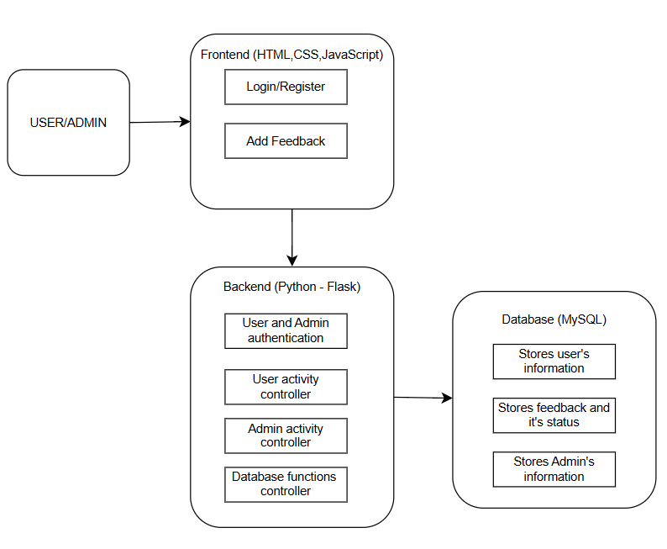

**Figure: System Architecture**

**Use case Diagram**

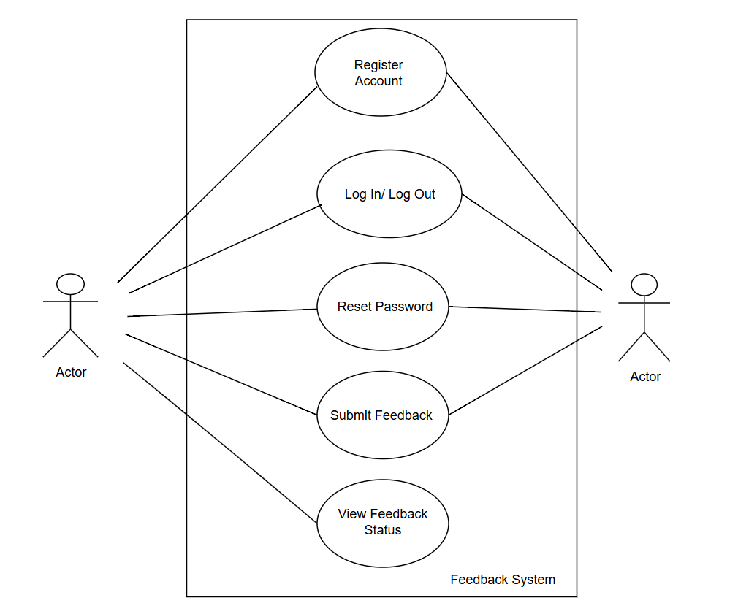

## 

**Figure: Use-case Diagram**

## Basic Work Flow Diagram

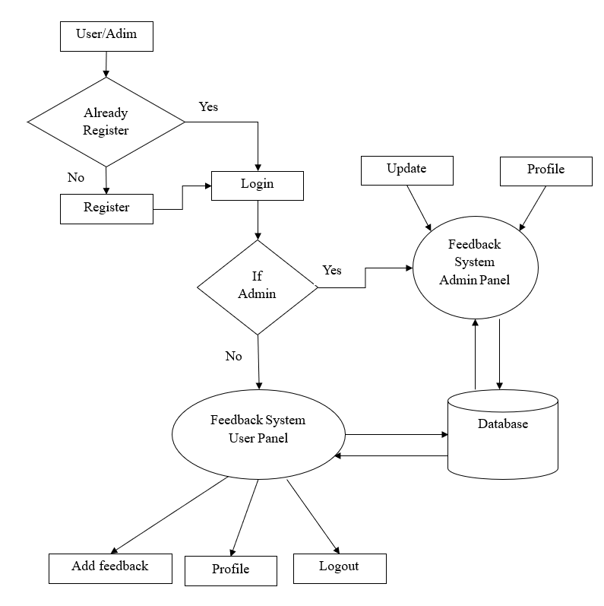

Figure: Basic Workflow Diagram

### 6. Entity Relationship Diagram

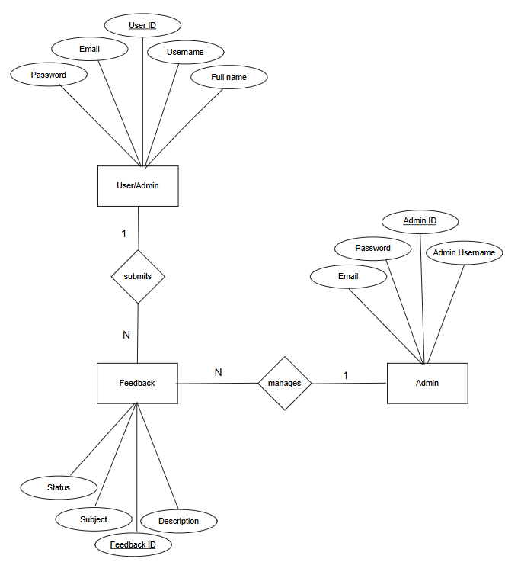Figure 6.2.4 ER Diagram

## 7. Project Schedule

The project schedule has been designed as per requirements and contains involved.

This project is schedule to be completed in about 2 months. Here we studied about the time taken to complete the analysis, planning, designing, coding and testing also about documentation and final presentation.

Table Project Schedule

|  |  |  |  |  |  |  |  |  |
| --- | --- | --- | --- | --- | --- | --- | --- | --- |
| Activities | May | May | May | May | June | July | July | July |
| 01-09 | 10-13 | 14-20 | 21-30 | 01-30 | 01-15 | 16-22 | 23-30 |
| Project  analysis |  |  |  |  |  |  |  |  |
| Proposal  Defense |  |  |  |  |  |  |  |  |
| Feasibility  study |  |  |  |  |  |  |  |  |
| Designing |  |  |  |  |  |  |  |  |
| Coding |  |  |  |  |  |  |  |  |
| Testing |  |  |  |  |  |  |  |  |
| Final  testing |  |  |  |  |  |  |  |  |
| Documentation |  |  |  |  |  |  |  |  |
| Final  Submission |  |  |  |  |  |  |  |  |

## 8 Development Cost Estimation

**Development cost estimation** is the process of predicting the total resources such as time, money, and effort required to complete an overall software project.

We use a bottom up approach, estimating each role’s effort and rate, then adding all for total cost. Here we break down tasks, assign resources, and aggregate costs control.

**Effort and Timeline**

Duration: 10 weeks (approximately)

Weekly hour per member: 36 hours

Total work hours: 36 (hours)* 10(weeks)* 4 (persons): 1440 hours

Table: Personnel Cost Estimation table

|  |  |  |
| --- | --- | --- |
| Role | Duration | Total cost(Rs) |
| Project Manager | 2.4 months | 76,000 |
| Frontend Developers | 2.4 months | 68,000 |
| Backend Developers | 2.4 months | 70,000 |
| QA Engineer | 2.4 months | 52,000 |
| UI/UX Designer | 2.4 months | 43,000 |
| Total |  | 3,09,000 |

## 

**Infrastructure and miscellaneous costs: Rs18500**

Grand total development cost: Rs 3,27,000

## 9. Deliverables

The deliverables are the tangible and intangible outcomes produced during the development of our project **Feedback System**. We will deliver project documentation, working web-application, source code files and presentation slides. These all items represent the final outputs submitted as part of the project and also serve as the proof of completion of the project.

10.Conclusion  
The **Feedback System** is a well-structured and practical solution aimed at simplifying the process of collecting, managing, and analyzing user feedback. By incorporating essential features such as secure login, feedback submission, admin control, and password recovery, the system effectively addresses the limitations of traditional manual feedback methods. Overall, this project not only enhances communication between users and administrators but also promotes transparency, accountability, and continuous improvement in services.

## 11. References

[1] “Understand system design concepts,” Tutorialspoint, https://www.tutorialspoint.com/system_analysis_and_design/system_design.htm (accessed May 8, 2025).

[2] “World-class complaints management system from Aptean,” Aptean.com, https://www.aptean.com/en-US/solutions/customer-experience/products/aptean-respond (accessed May 8, 2025).

[3] “Documentation,” Feedback module - MoodleDocs, https://docs.moodle.org/27/en/Feedback_module (accessed May 8, 2025).

[4] “Understand system design concepts,” Tutorialspoint, https://www.tutorialspoint.com/system_analysis_and_design/system_design.htm (accessed May 8, 2025).

[5] “Anthology evaluate,” Anthology, https://www.anthology.com/products/teaching-and-learning/assessment-management/anthology-course-evaluations (accessed May 8, 2025).